Smart Score Optimizer

1. Applied Real Time Use Scenario: Smart Score Optimizer

Problem Statement:
In the education sector, raw numerical data (marks) can be difficult to analyse quickly. Students and teachers often struggle to visualize comparative performance across different subjects. Traditional report cards provide numbers but lack visual insights, making it harder to identify weak areas or strengths at a glance.

The objective is to develop a Smart Result Visualizer that helps users:
* Input subject scores interactively.
* Validate data to ensure marks fall within a logical range
(0-10).
* Prevent errors caused by invalid non-numeric inputs.
* Visualize performance instantly using a Bar Chart for
Immediate analysis.

This project is implemented using Python, incorporating Matplotlib for visualization alongside core concepts like dictionaries, exception handling, and input validation.
2. Concepts Used

* External Libraries - Using matplotlib.pyplot to
generate professional grade graphical
representations (bar charts).
* Data Structures – Dictionaries are used to map
specific subjects to their respective scores,
keeping data organized.
* Exception Handling - try-except blocks are used
to catch non-integer inputs and logical errors and
preventing the program from crashing
unexpectedly.
* Input Validation - Ensuring scores remain within
the valid range (0-10) using if conditions and Value
Error.
* Functions - Modularizing the plotting
logic (plot_subject_scores) for cleaner code.

3. Solution Approach

The Smart Result Optimizer is structured into key functional steps:
* User Input Module – Accepts scores for Physics,
Chemistry, Maths, and Computer Science.
* Validation Layer – Checks if the input is a valid
integer and falls between 0 to 10, triggers an
error if invalid.
* Data Aggregation – Aggregates the valid inputs
into
a Python Dictionary for easy processing.
* Visualization Engine – Feeds the dictionary keys
(subjects) and values (Scores) into matplotlib to
render a bar chart.
* Error Management – Gracefully handles crashes
using try-except blocks to ensure a smooth user
experience.

4. Python Code Implementation

import matplotlib.pyplot as plt

def plot_subject_scores(scores):
try:
subjects = list(scores.keys())
values = list(scores.values())

# Bar chart
plt.figure(figsize=(6,4))
plt.bar(subjects, values, color="lightgreen", edgecolor="black")
plt.title("Subject Scores (out of 10)")
plt.xlabel("Subjects")
plt.ylabel("Scores")
plt.ylim(0, 10) # since max is 10
plt.show()

except Exception as e:
print(f"Error while plotting chart: {e}")

try:
physics = int(input("Enter Physics score (out of 10): "))
chemistry = int(input("Enter Chemistry score (out of 10): "))
maths = int(input("Enter Maths score (out of 10): "))
comp_sci = int(input("Enter Computer Science score (out of 10): "))

# Validate inputs
for val in [physics, chemistry, maths, comp_sci]:
if val < 0 or val > 10:
raise ValueError("Scores must be between 0 and 10.")

scores = {
"Physics": physics,
"Chemistry": chemistry,
"Maths": maths,
"Computer Science": comp_sci
}

print("\n✅ Scores entered successfully!")
print(scores)

plot_subject_scores(scores)

except ValueError as ve:
print(f"Input Error: {ve}")
except Exception as e:
print(f"Unexpected Error: {e}")
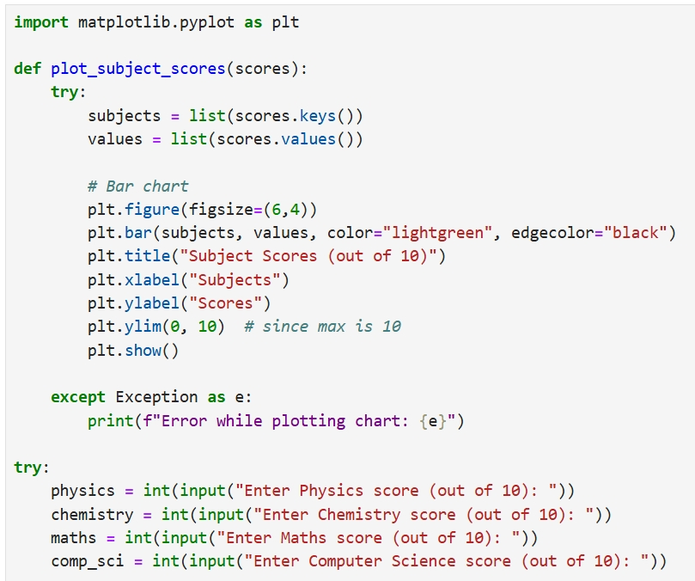
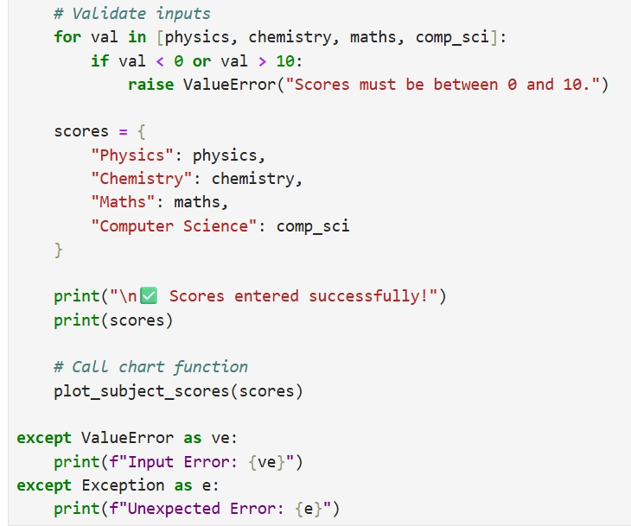
code
Code Output
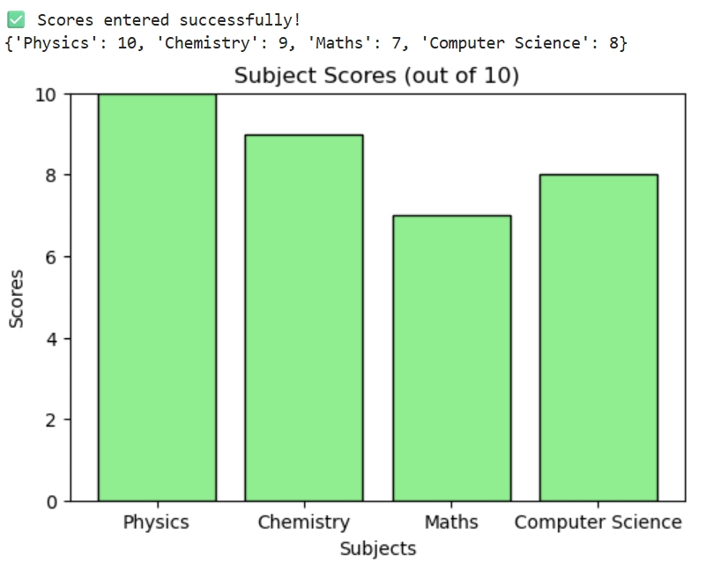
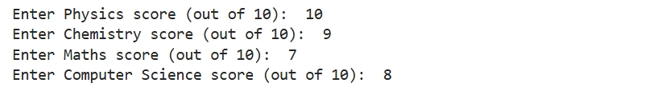
5. Code Breakdown & Insights

* Data Visualization (Matplotlib)
* The code uses plt.bar() to create a graphical representation of the
marks.
* plt.ylim(0, 10) ensures the graph scale is consistent, making it
easier to compare bars visually.

* Robust Input Validation
* A custom validation loop checks if val < 0 or val > 10.
* If a user enters an invalid number (e.g., 12 or -5), the program raises
a ValueError immediately, preventing incorrect graphs.

* Dictionary Usage
* scores.keys() and scores.values() are extracted dynamically which
allows plotting without hardcoding.

* Exception Handling
* The try-except block wraps the entire input process. If a user enters
text (e.g., "ten") instead of a number, the program catches the error
and prints a friendly message instead of crashing.

6. 📌 Advanced Discussion & Scalability

👨‍💼 Interviewer: Currently, this system generates a plot on the screen. How would you modify this to generate reports for 1,000 students automatically?

👨‍🎓 Student: Instead of using plt.show() which pauses the code to show a window, I would use plt.savefig(f"{student_id}_report.png"). This allows the script to loop through 1,000 students, generate their graphs in the background, and save them as image files automatically without human intervention.

Thank You

Name - Gaurav Rathore
Roll No -14
Subject - Principles of Programming Language
Course – BSc.Data Science

